**Compass MED D - Specialized Member Service Team (SMST) -** **Disenrollment Due to Enrolling in a Different** **Prescription Drug Plan (PDP)**

General Information

Review the Disenrollment Reason Field

DISENROL-NEW MCO

[Related Documents](https://policy.corp.cvscaremark.com/pnp/faces/DocRenderer#_Toc62650321)

**Description:** This document outlines the process and defines talking points the Specialized Member Services Team (SMST) will perform when a beneficiary disenrolls due to enrolling in a different Prescription Drug Plan (PDP).

|  |
| --- |
| General Information |

**Call Handling:**

* SilverScript (x9110) - Warm transfer to the SMST. Refer to [MED D - Guide to Transferring a Call](https://thesource.cvshealth.com/nuxeo/thesource/#!/view?docid=b9e1330e-9803-4dd8-a699-6ae62bb590d2).
* For all other clients - Refer to [Compass - Transferring Calls to Dedicated and Designated Client Teams](https://thesource.cvshealth.com/nuxeo/thesource/#!/view?docid=4c87518d-83f5-4884-8631-1f427b77da7d).
* **SMST CCRs** - Follow the process outlined in this document.

When a beneficiary enrolls in a different MED D Prescription Drug Plan (PDP) or Medicare Advantage Prescription Drug Plan (MAPD) the plan will receive notice through a **Transaction Reply code**. These numeric codes instruct the plan to take specific actions based on the code number and additional information within the transaction. When a beneficiary enrolls in a different PDP/MAPD, the Plan will receive **TRC 014**.

This code instructs the plan to **disenroll** the beneficiary on the first of the following month with a Special Election Period (SEP), or January 1 of the upcoming plan year if the code is received during the Annual Election Period (AEP).

**Once our plan receives TRC 014, we are unable to cancel this disenrollment**. The beneficiary **must contact the other plan to cancel their future enrollment** if they wish to remain enrolled in their current Plan.

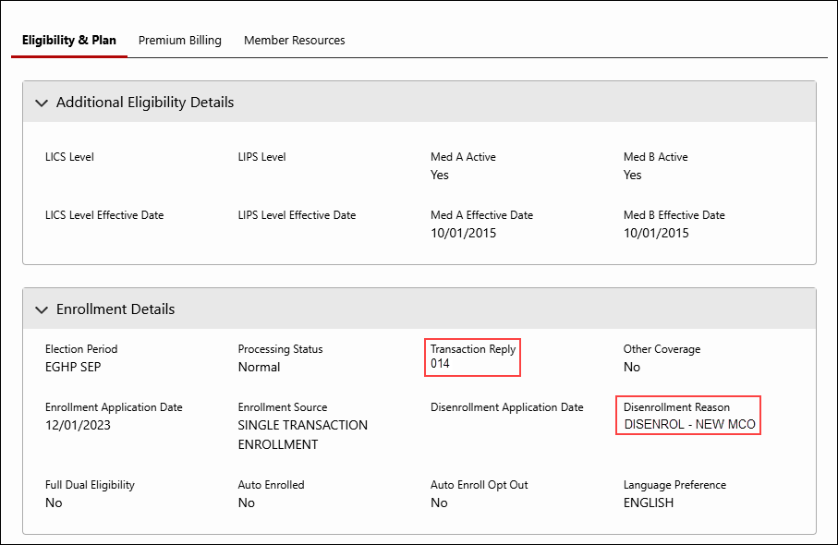

**Note:** When researching the reason why a beneficiary has been disenrolled, the CCR should always **review the** **Medicare D Landing page - Disenrollment Reason**. Additionally**,** the CCR should also**:**

* Review any disenrollment letters in the **Last 12 Months of Communications** hyperlink.
* Review all previous call notes in the **Member’s Recent Cases** located on the **Case Landing page** or **Member Snapshot Landing page** and the **Medicare D Landing page – Medicare D Alerts** panel.

Top of the Document

|  |
| --- |
| Review the Disenrollment Reason Field |

Follow the steps below**:**

|  |  |  |
| --- | --- | --- |
| **Step** | **Action** | |
| **1** | In the **Medicare D Landing page – Enrollment Details** section, review the **Transaction Reply** and **Disenrollment Reason** field. | |
| **If…** | **Then…** |
| Transaction Reply**:** 014  and  Disenrollment Reason**:** DISENROLL-NEWMCO | Proceed to DISENROL-NEW MCO. |
| Any other Transaction Reply and Disenrollment Reason | Refer to the [Compass MED D - Specialized Member Services Team (SMST) - Compass Disenrollment Reasons Guide.](https://thesource.cvshealth.com/nuxeo/thesource/#!/view?docid=4156e604-0094-43df-a7e5-302a56c4762f) |

Top of the Document

|  |
| --- |
| DISENROL-NEW MCO |

The CCR will follow the steps below to address the beneficiary’s issue**:**

|  |  |  |  |
| --- | --- | --- | --- |
| **Step** | **Action** | | |
| **1** | In the **Medicare D Landing page,** review the **Enrollment Source** field. | | |
| **If…** | | **Then…** |
| **Enrollment Source:**   * CMS Auto Enrollments - TRC117 * CMS Facilitated - TRC118 * CMS Reassignment - TRC212 | | Refer to [MED D SilverScript – Annual Reassignment of Low Income Subsidy (LIS) Eligible Beneficiaries](https://thesource.cvshealth.com/nuxeo/thesource/#!/view?docid=51e87c92-ddb1-4f14-b127-c9d5cc9afca7). |
| **Auto Enrolled:** No | | Proceed to next step |
| **2** | Confirm that a **DDISE** letter in the **Last 12 Months of Communications (OneClick)** was sent to the beneficiary and obtain the disenrollment date.  Proceed to the next step. | | |
| **3** | * Our records show that you will be disenrolled from SilverScript XX/XX/XXXX due to enrolling into another prescription drug plan (PDP). Since SilverScript did not submit the disenrollment request, we are unable to cancel the disenrollment for you. * If you would like to remain enrolled with SilverScript, you will need to contact the plan you enrolled in and cancel your enrollment, or you can submit a new enrollment for the plan you wish to be enrolled in. However, please be aware you will need to have a valid enrollment period (i.e. AEP or SEP). * Have you contacted the other plan to cancel your future enrollment?   **Notes:**   * If the beneficiary is not aware of a new enrollment, you may assist the beneficiary by researching MARx for the Plan ID (S#####) and performing an internet search to determine the carrier. * If the beneficiary would like to submit a new enrollment for SSI PDP, warm transfer to an Enrollment Agent. Refer to [MED D - Guide to Transferring a Call](https://thesource.cvshealth.com/nuxeo/thesource/#!/view?docid=b9e1330e-9803-4dd8-a699-6ae62bb590d2). | | |
| **If…** | **Then…** | |
| The beneficiary has **not** contacted the other plan to cancel their enrollment. | Please contact the plan you enrolled in and submit a request to cancel your future enrollment. Once we receive information from Medicare showing the enrollment has been cancelled, you will receive a letter in the mail. | |
| The beneficiary **has** contacted the other plan. | Verify in **MARx** if beneficiary’s future enrollment is cancelled and beneficiary is reinstated into the Plan.  **Note:** Contact the Senior Team (SRT) for assistance with:   * Reviewing MARx Part D eligibility; and/or * Opening Access to Care if necessary (**3 days or less of medication**). | |
| **If other plan is…** | **Then…** |
| Not cancelled in **MARx** | Inform the beneficiary they may contact Medicare toll-free at:  **1-800-MEDICARE (1-800-633-4227),** 24 hours a day, 7 days a week.   * TTY users should call 1-877-486-2048. |
| Cancelled in **MARx,** butthe beneficiary has **not** been reinstated. | We are only able to process your reinstatement once we have received notice from Medicare. When your reinstatement has been approved and processed, you will receive a letter in the mail. Please note, this may take up to 10 days or more during busy times of the year such as the Annual Enrollment Period.  Click the Create Support Task button and submit the following Support Task in Compass**:**  Refer to**:** [Compass - Create a Support Task](https://thesource.cvshealth.com/nuxeo/thesource/#!/view?docid=64f18e5a-4d56-4175-ba8e-e7d094e501d6)  **Task Type:** Disenrollment - Cancellation of Voluntary Disenrollment  Complete all required fields marked with an asterisk (*).  **Task Notes:** Beneficiary called to advise they were involuntarily disenrolled due to enrolling into another plan and cancelling that plan. Beneficiary can be reached at <current phone number> at <best time to contact>. Beneficiary was informed to continue to use plan services. Eligibility was verified in <MARx>. |
| **4** | * Thank you for your time today. * As a quality measure, have I fully answered and resolved <your/the beneficiary’s> question(s) to <your/the beneficiary’s> satisfaction? | | |
| **If…** | | **Then…** |
| Yes | | Close the call**:**   * Address any other issues. * Document and close the call according to existing policies and procedures, including all options discussed. Refer to the  [Compass - Call Documentation](https://thesource.cvshealth.com/nuxeo/thesource/#!/view?docid=0296717e-6df6-4184-b337-13abcd4b070b) and [Compass MED D - Call Documentation Job Aid](https://thesource.cvshealth.com/nuxeo/thesource/#!/view?docid=433711aa-8fa6-447c-872b-bd69cd6cd7c0). |
| No | | * Ask additional probing questions to attempt to resolve remaining questions or concerns. * If unable to resolve the questions/concerns, transfer the call to a supervisor. |

Top of the Document

|  |
| --- |
| **Related Documents** |

* Grievance Standard Verbiage (for use in Discussion with Beneficiary) section in [Compass MED D - Grievances Index](https://thesource.cvshealth.com/nuxeo/thesource/#!/view?docid=70034f51-77df-49a4-ae97-7d3d63b216b3)
* [MED D Enrollment - FAZAL](https://thesource.cvshealth.com/nuxeo/thesource/#!/view?docid=db8c2342-e9e4-467b-8cd9-ccb712533400)
* [MED D - SHIP Counselor Calls for CVS Caremark Part D Plans](https://thesource.cvshealth.com/nuxeo/thesource/#!/view?docid=3f853166-b8d0-477c-8fae-9d6ab8ea98f1)
* [Compass MED D - Appointed Representative Form (AOR) or Power of Attorney (POA)](https://thesource.cvshealth.com/nuxeo/thesource/#!/view?docid=64c3fc62-48c3-4ad3-ae83-c736cebd521b)
* [Compass MED D - SilverScript and Blue MedicareRx (NEJE) - Enrollment Related Support Tasks](https://thesource.cvshealth.com/nuxeo/thesource/#!/view?docid=39a75bb6-425d-4eb7-a436-036f5da9d31a)
* [MED D - Election Periods for Enrollment and Disenrollment (AEP, IEP, SEP)](https://thesource.cvshealth.com/nuxeo/thesource/#!/view?docid=23d6bdd2-b914-4dd9-bf92-05f5d0f1088a)
* [Compass MED D - CMS Passive Enrollment in MMP - Required Voluntary Disenrollment from the PDP, Opt-Out and Disenrollment from the MMP](https://thesource.cvshealth.com/nuxeo/thesource/#!/view?docid=4d52d68c-a6f6-40c7-9c55-c3b3a710f451)

**Parent SOP:**

* MEDS-0041**:** [Medicare Part D Voluntary Disenrollment, CVS Caremark Part D Services, L.L.C., Policy and Procedure](https://policy.corp.cvscaremark.com/pnp/faces/DocRenderer?documentId=MEDS-0041)
* MEDS-0006**:** [Medicare Part D - Cancellation of Enrollment and Disenrollment Policy and Procedure, CVS Caremark Part D Services, L.L.C.](https://policy.corp.cvscaremark.com/pnp/faces/DocRenderer?documentId=MEDS-0006)
* CALL-0048**:** [Medicare Part D - Customer Care Call Center Requirements, CVS Caremark Part D Services, L.L.C.](https://policy.corp.cvscaremark.com/pnp/faces/DocRenderer?documentId=CALL-0048)

**Abbreviations/Definitions:**

* [Abbreviations / Definitions](https://aetnao365.sharepoint.com/sites/PolarisPHDDocumentationReview/Shared%20Documents/AppData/Local/Microsoft/AppData/Local/Microsoft/AppData/Local/Microsoft/Windows/INetCache/Content.Outlook/AppData/Local/Microsoft/Windows/INetCache/Content.Outlook/2ULSS2XL/CMS-2-017428)